IRIS Plot User Documentation

This document covers programs, as well as functionality, of the IRIS plot Shiny Page.

Contents

What is IRIS Plot 1

How is the page used 1

Controls 2

# What is IRIS Plot

The Iris plot is a quick and dirty look at performing some comparisons against the different columns associated with the IRIS data set that is included with R. The program starts at the default setting of comparing the “Sepal.Length” to the “Petal.Length” data points, without showing the regression line. The default for points is 25. The points are random (No Seed). The user can select how many points to use, what variables to compare, and if a regression line is desired. There is no limitation on the variables, so the same variables can be selected for the first and second variables.

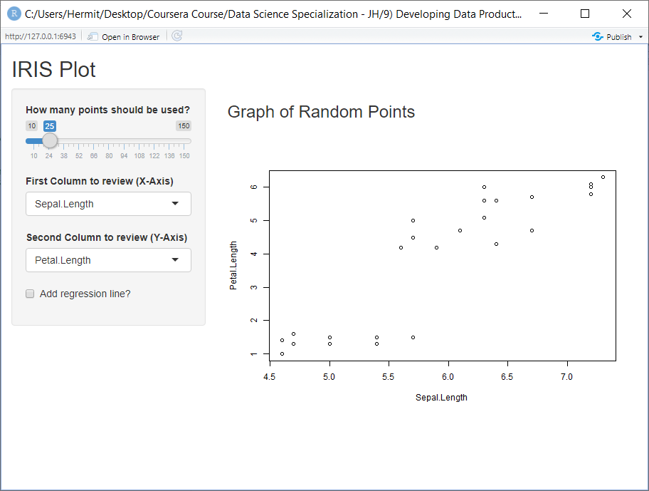

# How is the page used

The user may select any combination. The plot will reconfigure after each update. This will allow the user to do quick compares without having to stop and click a process button. The controls for the page are as follow.

## Controls

**Points**: Titled “How many points should be used?”. This slide Bar goes from 10 to 150. With a default of 25. This control determines the number of points from the IRIS data set that will be used to create the plot.

**First Column**: Titled “First Column to review (X-Axis)”. Selects the column to be represented on the X Axis of the plot. The “Sepal.Length” column is defaulted to this control. Thought any column from the data set can be selected; "Sepal.Length", "Sepal.Width", "Petal.Length", "Petal.Width".

**Second Column**: Titled “Second Column to review (Y-Axis)”. Selects the column to be represented on the Y Axis of the plot. The “Petal.Length” column is defaulted to this control. Thought any column from the data set can be selected.

**Regression Line**: Titled “Add regression line?”. This control will add/remove a regression line from the plot.